

Department of Islamic Studies

Time Table
Degree Program: MPI Semester: 2nd

Days | 09:00-10:00 | 10:00-11:00 | 11:00-12:00 | 12:00-12:30 | 12:30-01:30 | 01:30- 02:30 | 02:30-03:30
Saturday | ISL-707  Dr. Ammara Rehman  Room# | ISL-707  Dr. Ammara Rehman  Room# | ISL-707  Dr. Ammara Rehman  Room# | Break | ISL-706  Dr Hifsa Munawar  Room# | ISL-706  Dr Hifsa Munawar  Room# | ISL-706  Dr Hifsa Munawar  Room#
Sunday | ISL-718  Prof. Dr. Matloob Ahmad  Room# | ISL-718  Prof. Dr. Matloob Ahmad  Room# | ISL-718  Prof. Dr. Matloob Ahmad  Room# | Break | ISL-705  Prof. Dr. Matloob Ahmad  Room# | ISL-705  Prof. Dr. Matloob Ahmad  Room# | ISL-705  Prof. Dr. Matloob Ahmad  Room#

Subjects | Course code | Instructor name
Economics in Islamic Perspective | ISL-718 | Prof. Dr. Matloob Ahmad
Comparative Study of Religions | ISL-705
Study of Seerah & Islamic Mysticism | ISL-707 | Dr. Ammara Rehman
Study of Fiqh & Usool e Fiqh | ISL-706 | Dr. Hifsa Munawar

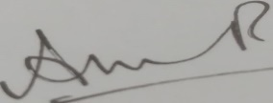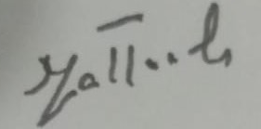
Dr Ammara Rehman Prof. Dr. Matloob Ahmad
HOD/Assistant Professor Dean Faculty of Arts and Social Sciences
Department of Islamic Studies The University of Faisalabad

